List of R packages

R is the language of data science which includes a vast repository of packages. These packages appeal to different regions which use R for their data purposes. CRAN has 10,000 packages, making it an ocean of superlative statistical work. There are lots of packages in R, but we will discuss the important one.

There are some mostly used and popular packages which are as follows:

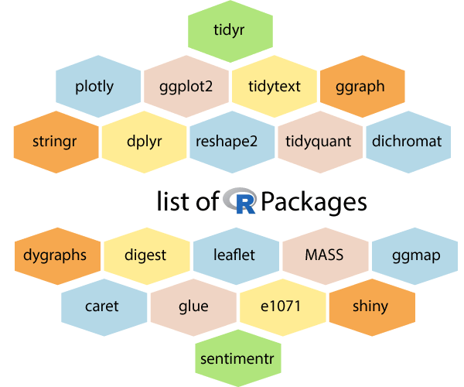

1) tidyr

The word tidyr comes from the word tidy, which means clear. So the **tidyr** package is used to make the data' tidy'. This package works well with dplyr. This package is an evolution of the reshape2 package.

2) ggplot2

R allows us to create graphics declaratively. R provides the **ggplot** package for this purpose. This package is famous for its elegant and quality graphs which sets it apart from other visualization packages.

3) ggraph

R provides an extension of ggplot known as **ggraph**. The limitation of **ggplot** is the dependency on tabular data is taken away in ggraph.

4) dplyr

R allows us to perform data wrangling and data analysis. R provides the **dplyr** library for this purpose. This library facilitates several functions for the data frame in R.

5) tidyquant

The tidyquant is a financial package which is used for carrying out quantitative financial analysis. This package adds to the **tidyverse** universe as a financial package which is used for importing, analyzing and visualizing the data.

6) dygraphs

The dygraphs package provides an interface to the main JavaScript library which we can use for charting. This package is essentially used for plotting time-series data in R.

7) leaflet

For creating interactive visualization, R provides the **leaflet** package. This package is an open-source JavaScript library. The world's popular websites like the New York Times, Github and Flicker, etc. are using leaflet. The leaflet package makes it easier to interact with these sites.

8) ggmap

For delineating spatial visualization, the **ggmap** package is used. It is a mapping package which consists of various tools for geolocating and routing.

9) glue

R provides the **glue** package to perform the operations of data wrangling. This package is used for evaluating R expressions which are present within the string.

10) shiny

R allows us to develop interactive and aesthetically pleasing web apps by providing a **shiny** package. This package provides various extensions with HTML widgets, CSS, and JavaScript.

11) plotly

The plotly package provides online interactive and quality graphs. This package extends upon the JavaScript library **-plotly.js**.

12) tidytext

The **tidytext** package provides various functions of text mining for word processing and carrying out analysis through ggplot, dplyr, and other miscellaneous tools.

13) stringr

The stringr package provides simplicity and consistency to use wrappers for the '**stringi**' package. The stringi package facilitates common string operations.

14) reshape2

This package facilitates flexible reorganization and aggregation of data using melt () and decast () functions.

15) dichromat

The R dichromat package is used to remove Red-Green or Blue-Green contrasts from the colors.

16) digest

The digest package is used for the creation of cryptographic hash objects of R functions.

17) MASS

The **MASS** package provides a large number of statistical functions. It provides datasets that are in conjunction with the book "Modern Applied Statistics with S."

18) caret

R allows us to perform classification and regression tasks by providing the caret package. **CaretEnsemble** is a feature of caret which is used for the combination of different models.

19) e1071

The **e1071** library provides useful functions which are essential for data analysis like Naive Bayes, Fourier Transforms, SVMs, Clustering, and other miscellaneous functions.

20) sentimentr

The sentiment package provides functions for carrying out sentiment analysis. It is used to calculate text polarity at the sentence level and to perform aggregation by rows or grouping variables.